LAB 3

Initial lab environment setup



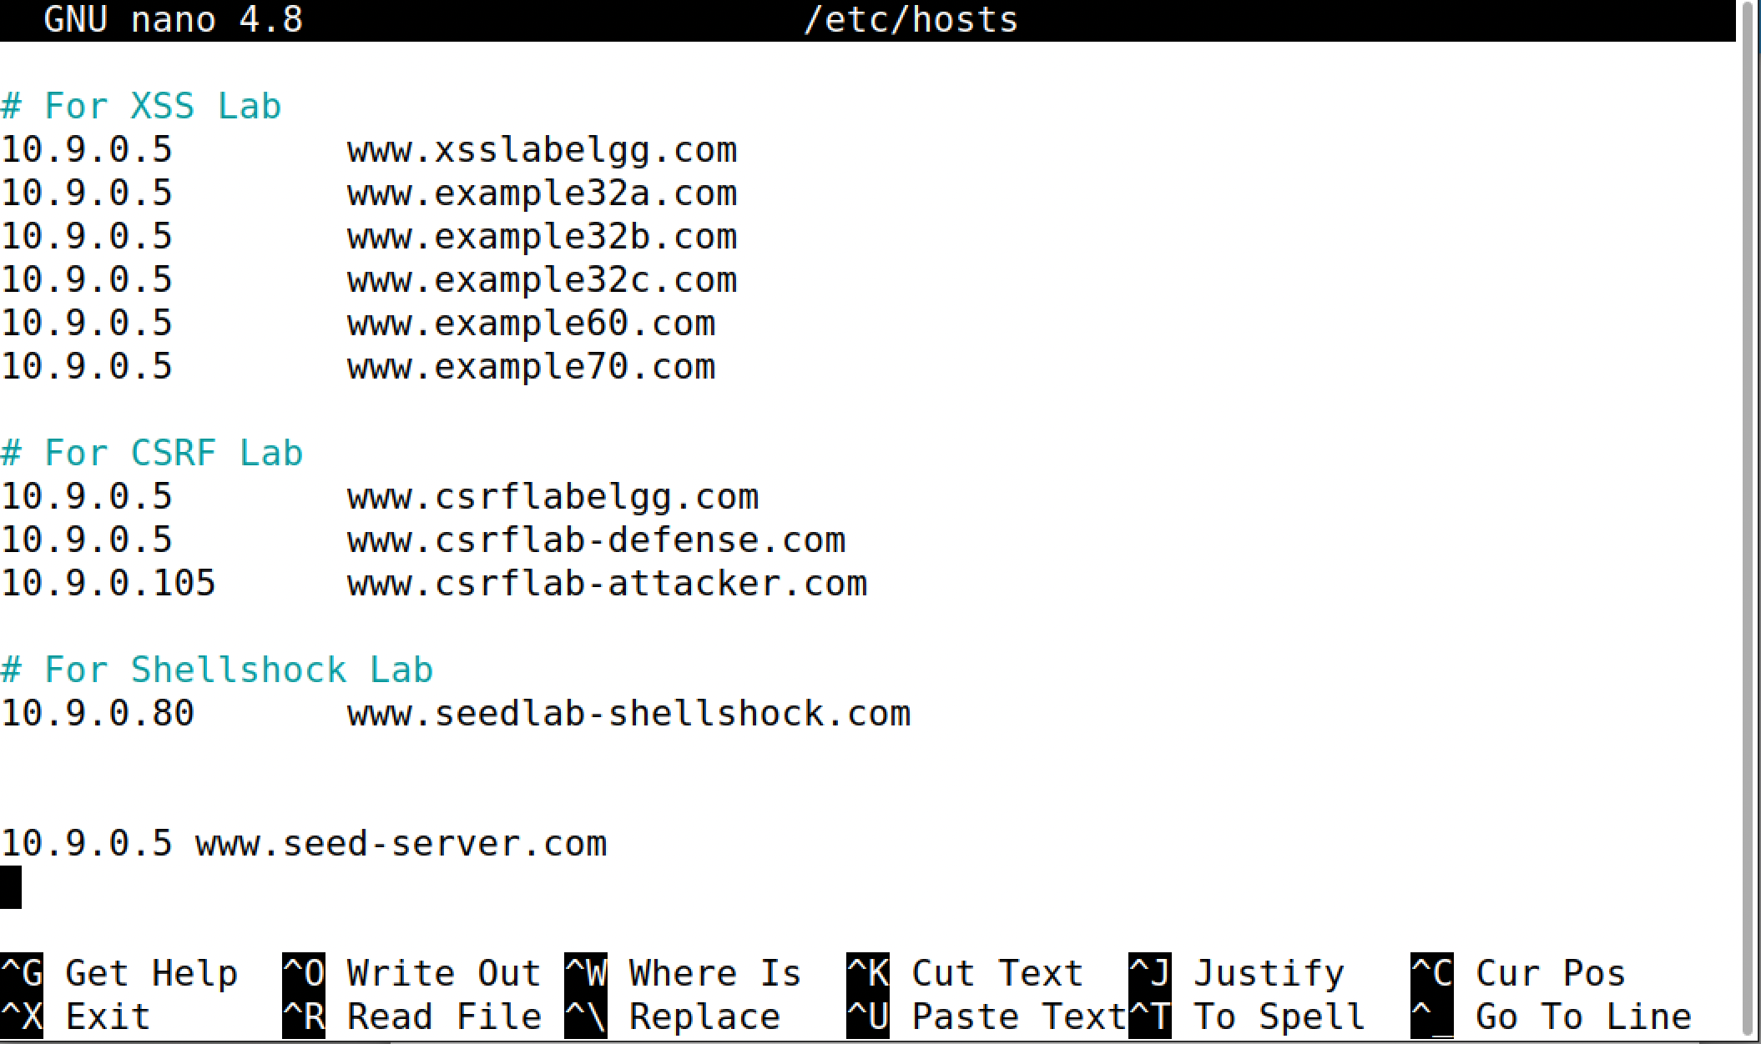

To build containers following steps are to done.

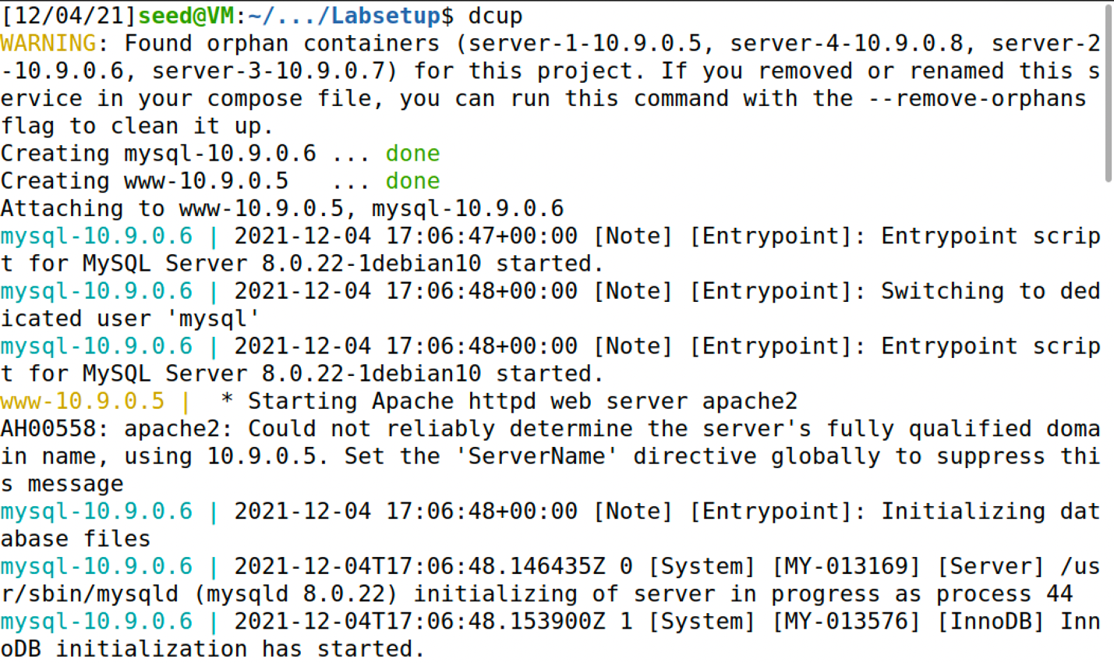

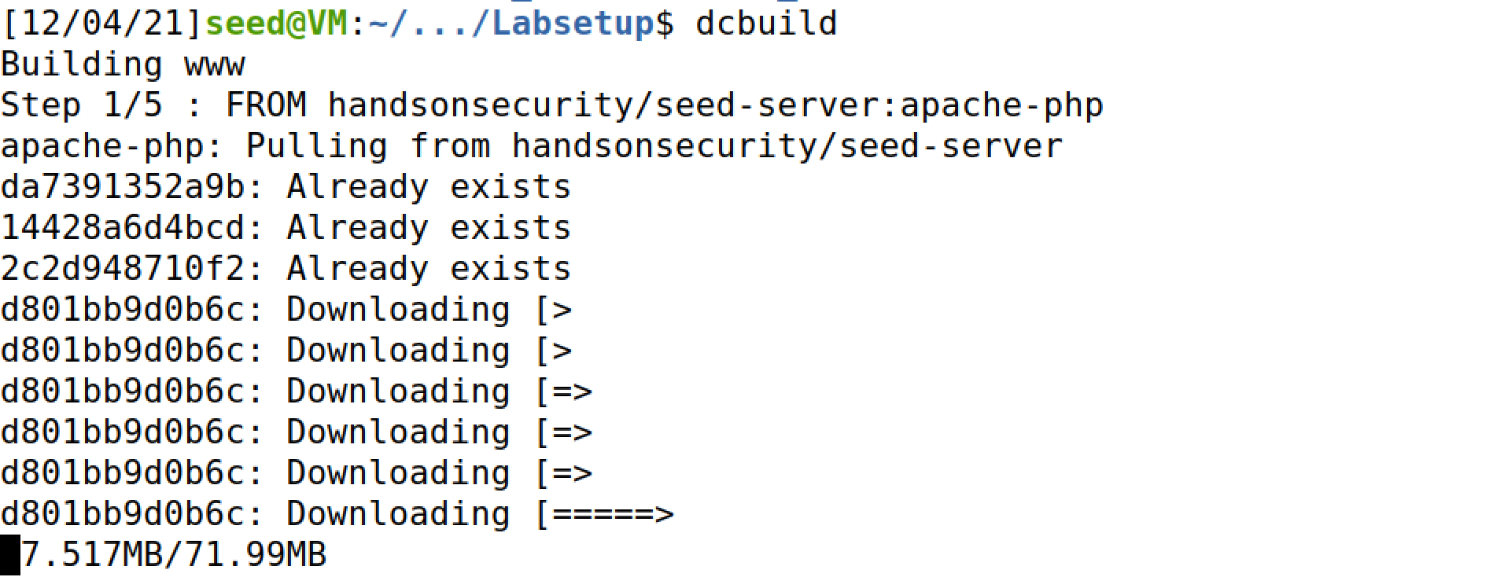

To find IDs of containers we use dockps

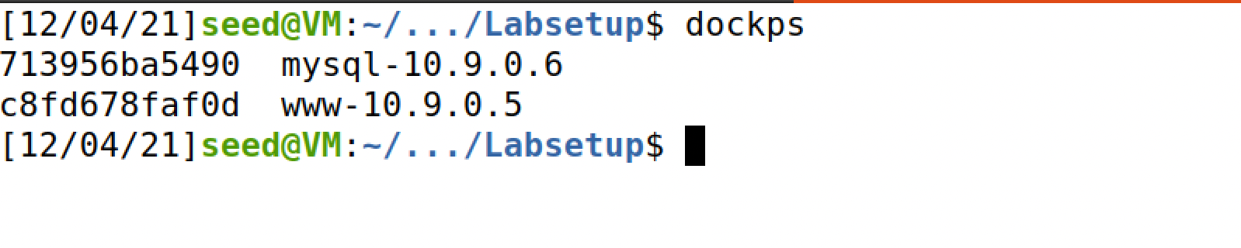

TASK 1: Getting shell access to mysql’s container and using mysql client program to interact with database.

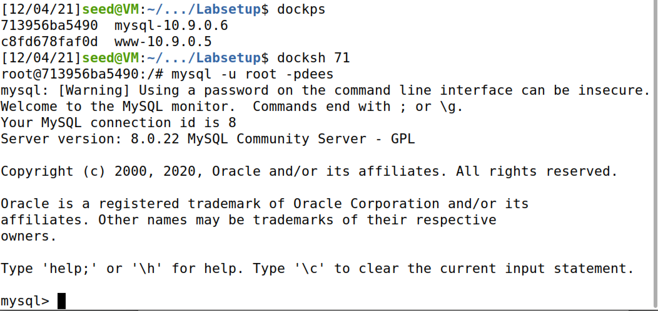

The below figure shows that available tables

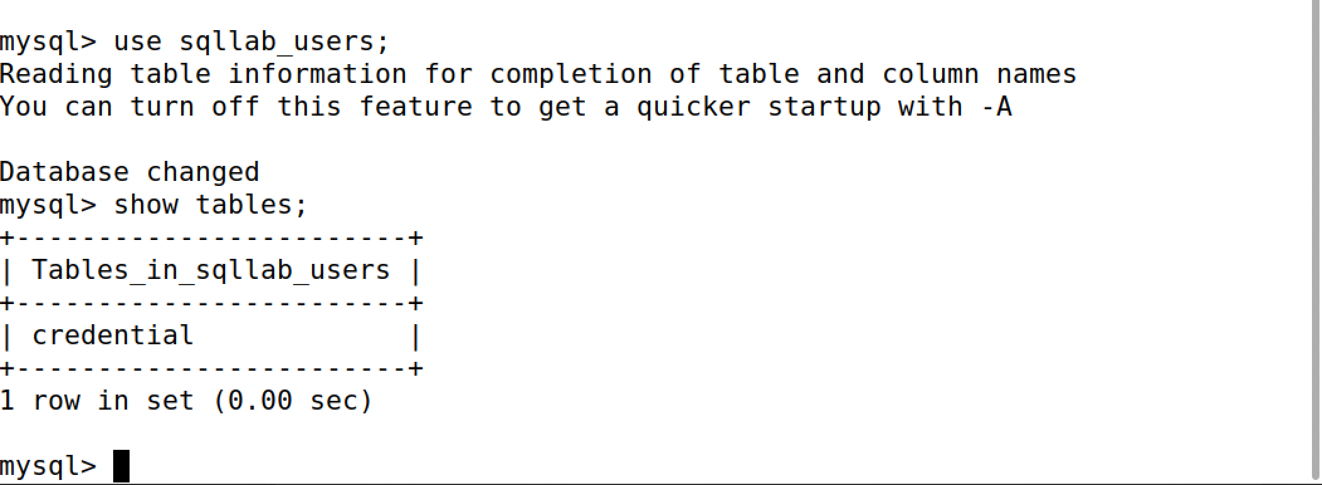

The below figure gives you names and types which has to be used in other queries

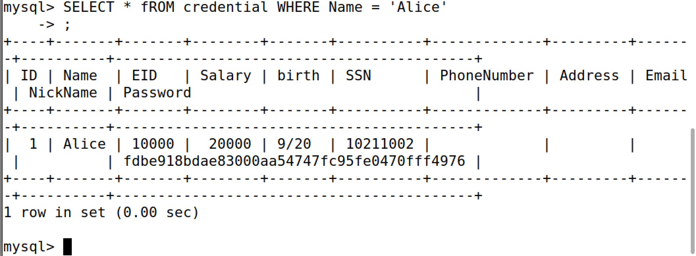

TASK2.1

The code WHERE name= ’$input_uname’ and Password=’$hashed_pwd’" is vulnerable and can be exploited. The values given by the user will be taken as it is and will be assigned to the original sql statement. Here we use (‘;#) closing inverted comma ,semi colon and pound key. The pound key is used because the sql interpereter ignores the remaining code line, therby removing the requirement of entering the password and checking it in the “and Password=’$hashed_pwd’” part of the code.

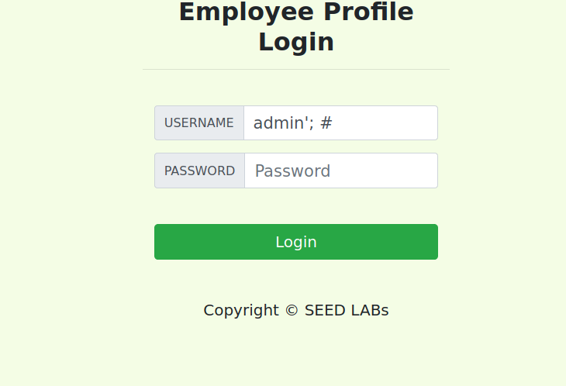

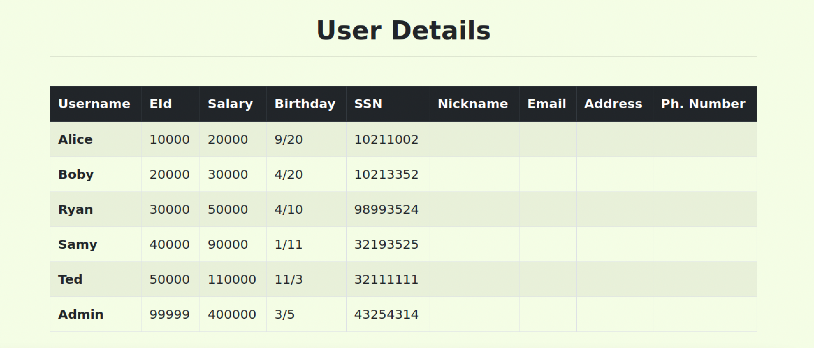

TASK2.2 SQL Injection Attack from command line.

First trying with legitimate username and password to see what is retrieved.

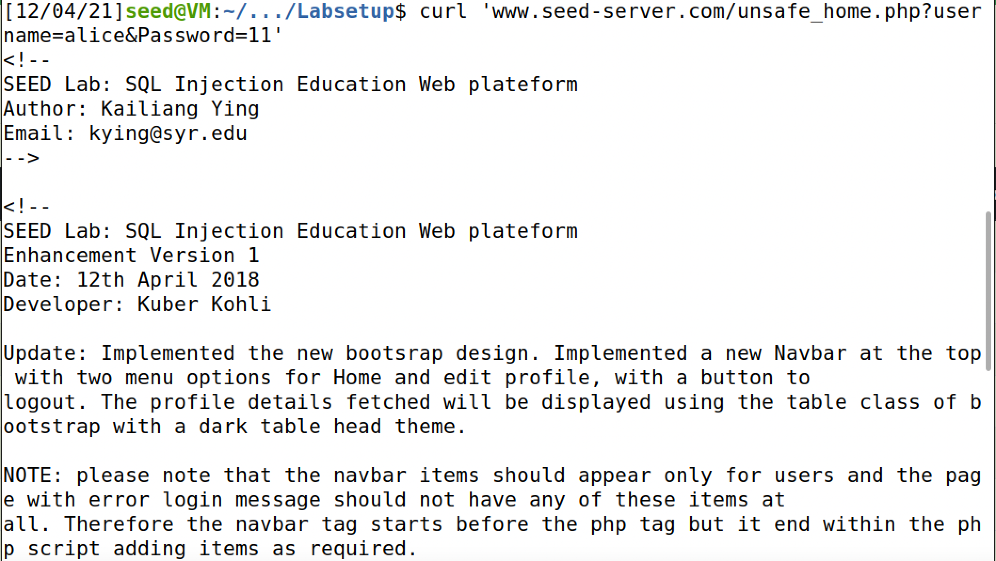

Now we try injection similar to the previous task. Here we use %27 for ‘ , %3B for ; and %23 for #.

Below figure shows that we retrieved Alice’s information successfully.

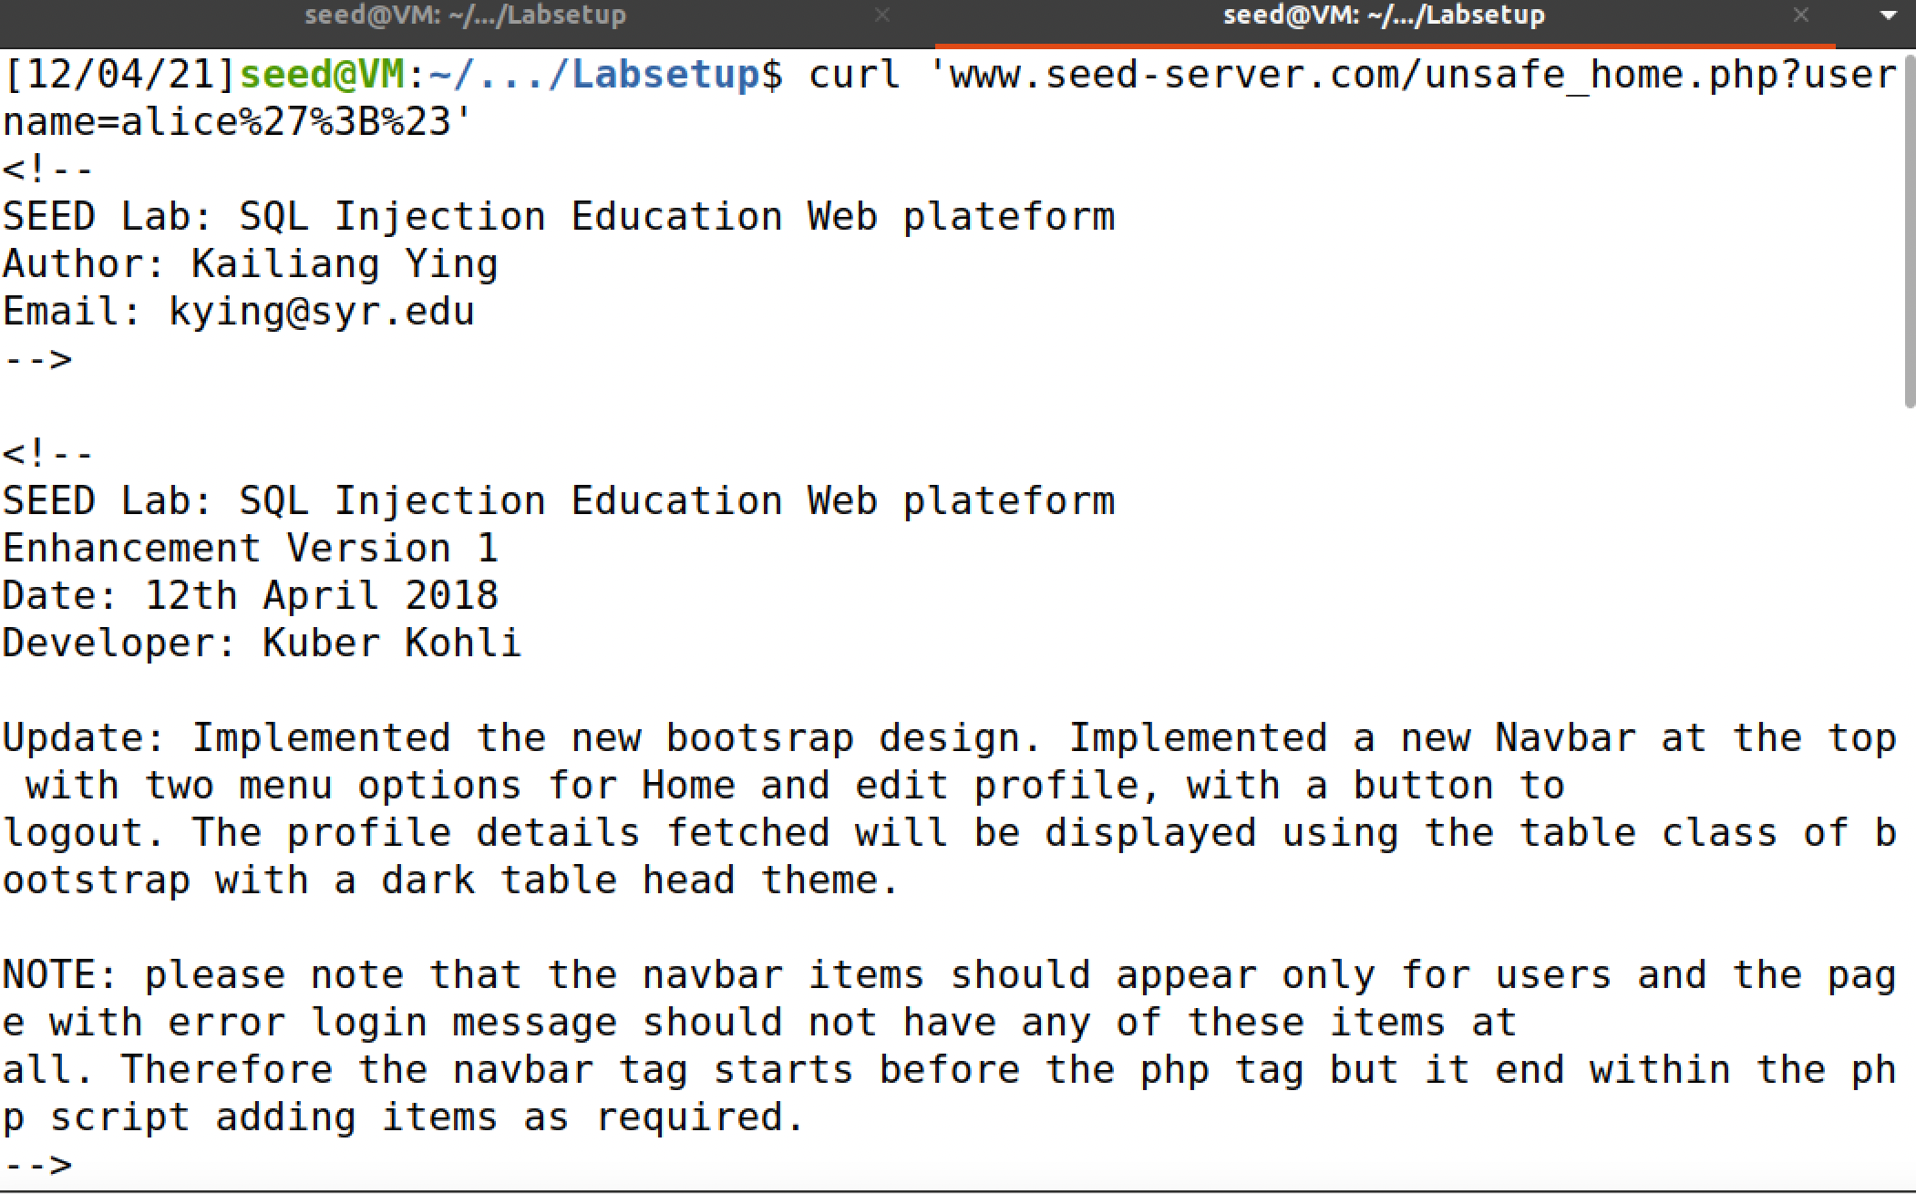

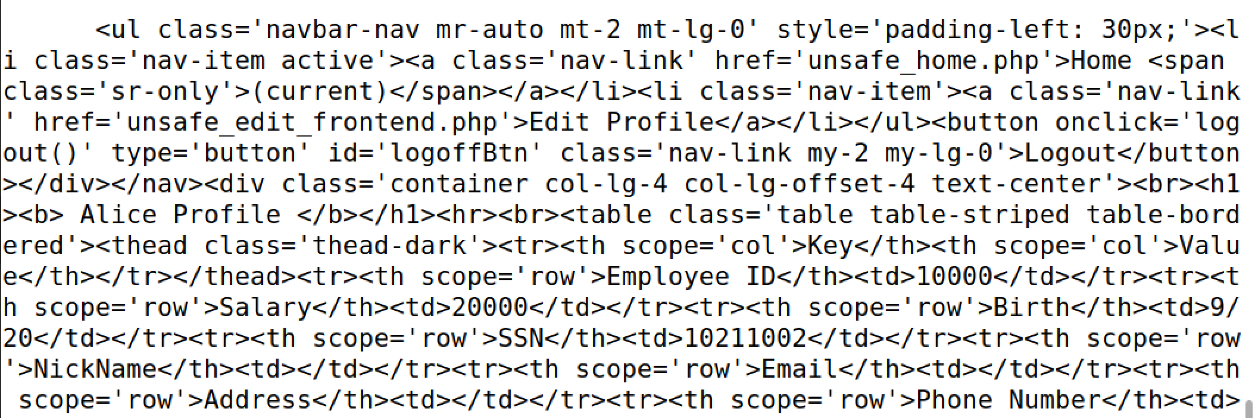

TASK 2.3 Append a new SQL statement.

Here we modify the database using the same vulnerability in the login page.

Here in order to pass the second statement in the multiple combinations of special characters were tried. The pound key ‘#’ was tried before and after the statement so that authentication can be avoided. I observed that the use of # after the statement continued to validate the password whereas the use of # before the statement overlooked the second SQL statement. Also union and AND operators dint work here. On further research I learnt that SQL has a countermeasure that does not allow query stacking by default.

Below given are some of the examples of combinations I tried.

alice'; UPDATE credential SET salary = 999 WHERE name=’Alice’;#

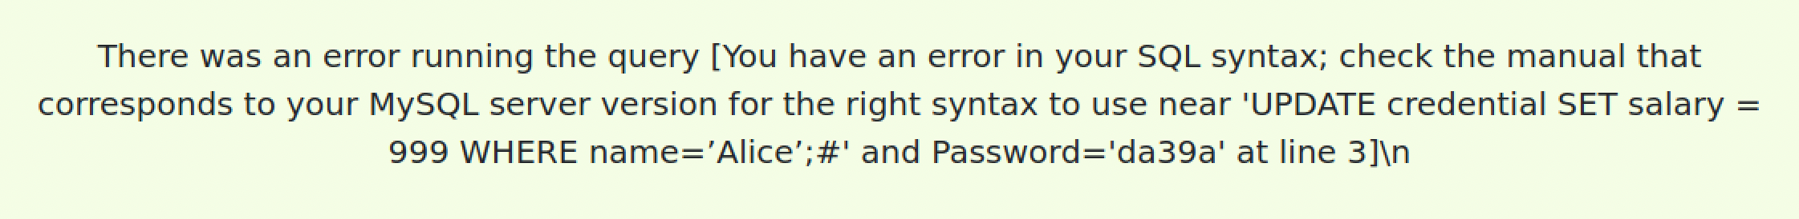

alice';# UPDATE credential SET salary = 999 WHERE name=’Alice’;#

alice';# Update credential SET salary ='0';

alice';# UPDATE credential SET salary = 999 WHERE name=’Alice’;

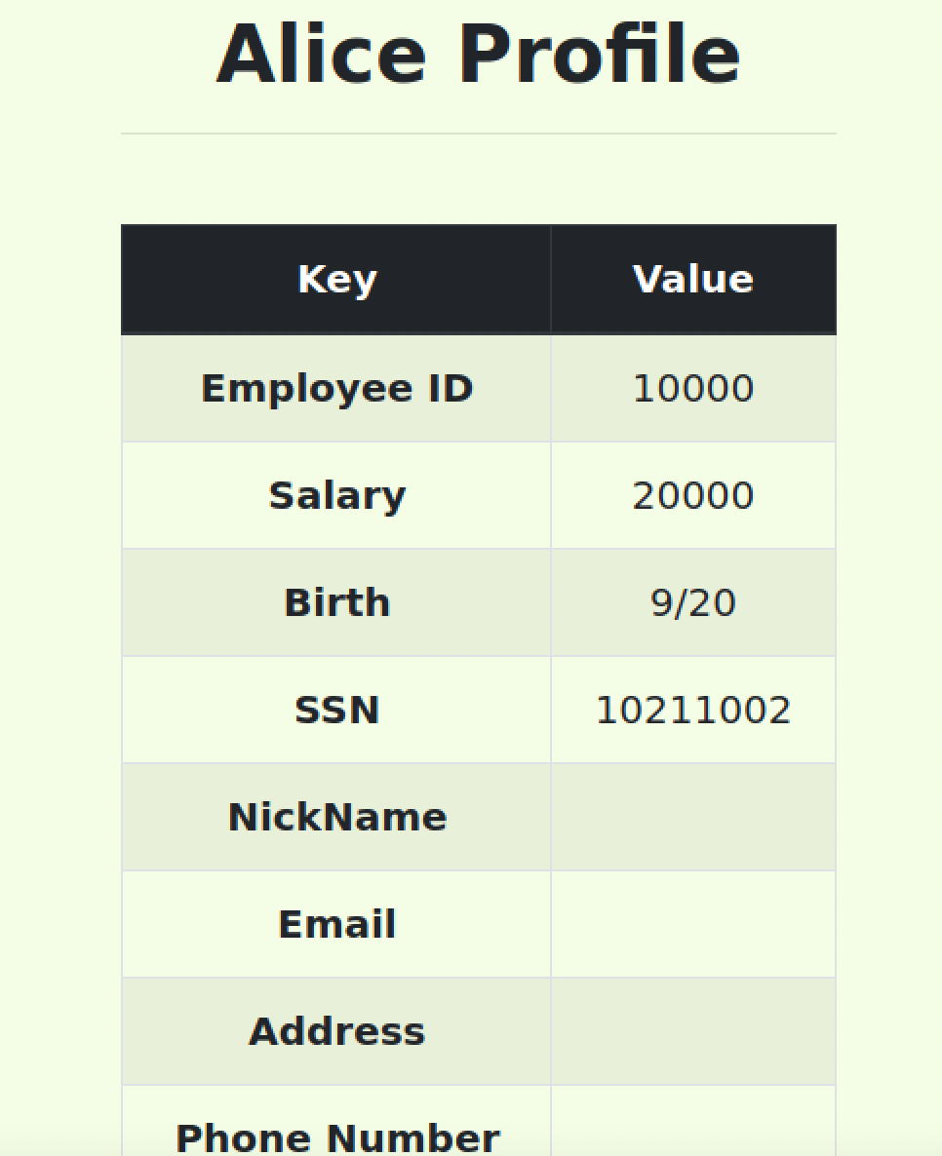

TASK 3.1 SQL Injection Attack on UPDATE Statement

1. Modify your own salary

If a SQL injection vulnerability happens to an UPDATE statement, the damage will be more severe, because attackers can use the vulnerability to modify databases.. This attack is possible because the user input goes into the sql statement ,just filling in the values in the plain sql query that takes values and assigns it to the column specified in the query.

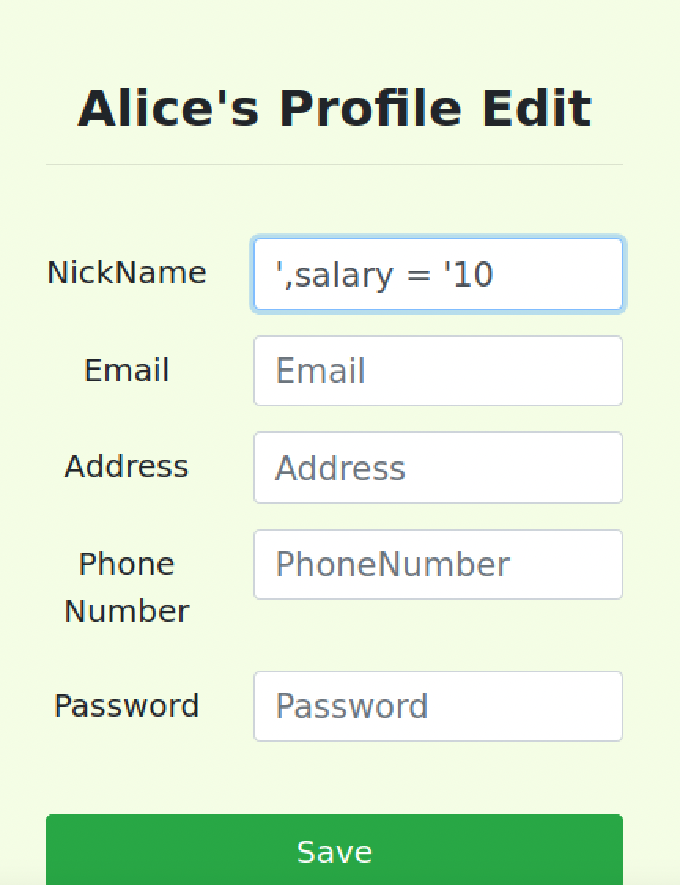

TASK3.2: Modify other people’ salary.

Here I am updating boss’s salary using alice’s account with the clause

‘,salary = ‘1’ where name = ‘boby’;#

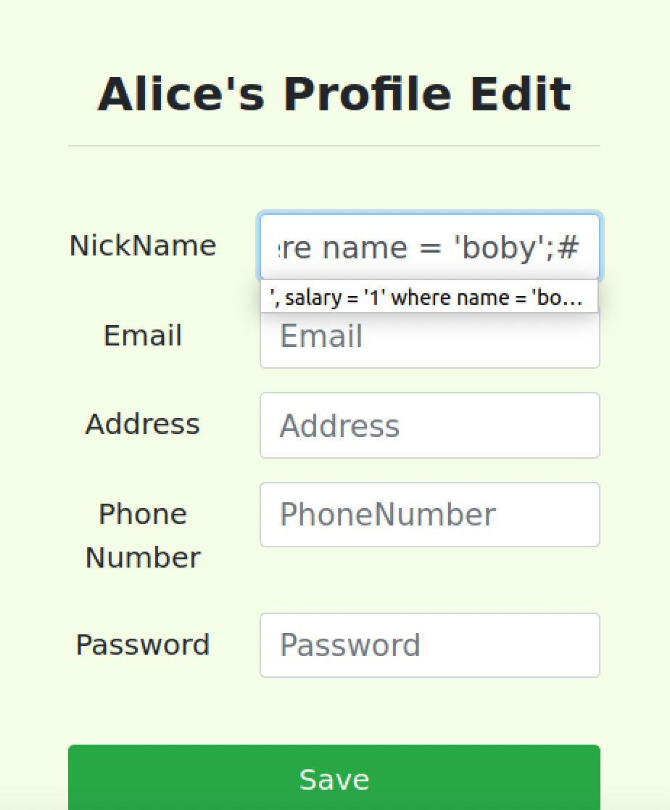

Now when we check’s boby’s profile we can see that the salary has changed.

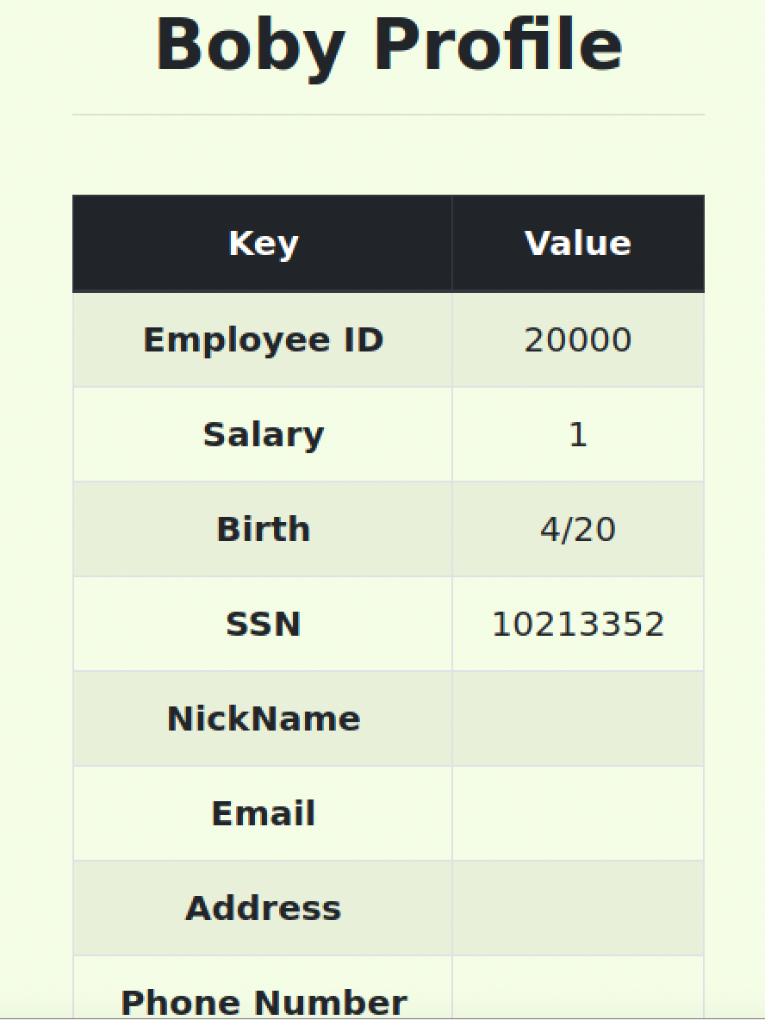

TASK 3.2 Modify other people’ password.

Here we are going to modify boby’s password sing Alice’s profile. The new password to be set is 123. To do this: converting 123 to SHA-1 as 40bd001563085fc35165329ea1ff5c5ecbdbbeef and passing it as follows:

', password = '40bd001563085fc35165329ea1ff5c5ecbdbbeef' where name = 'boby';#

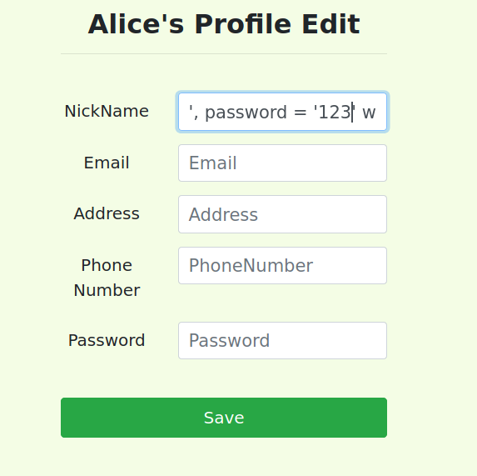

Later when we try to login it does not authenticate.



Now when we update the password it can be observed that the authentication was successful and we can see the details.

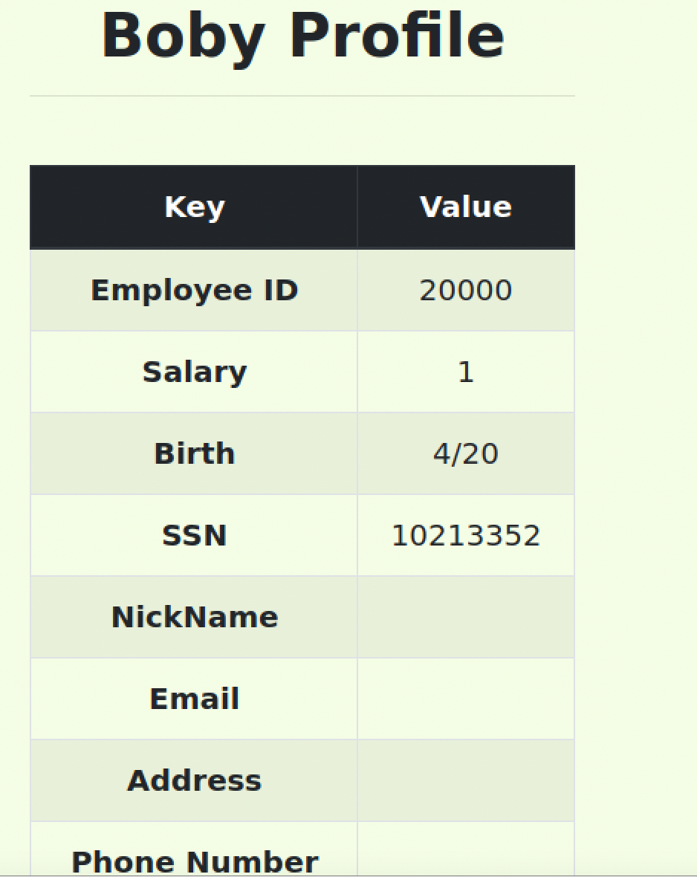

TASK 4: Countermeasure — Prepared Statement

Making updates to the code so that we can add the prepared statement.

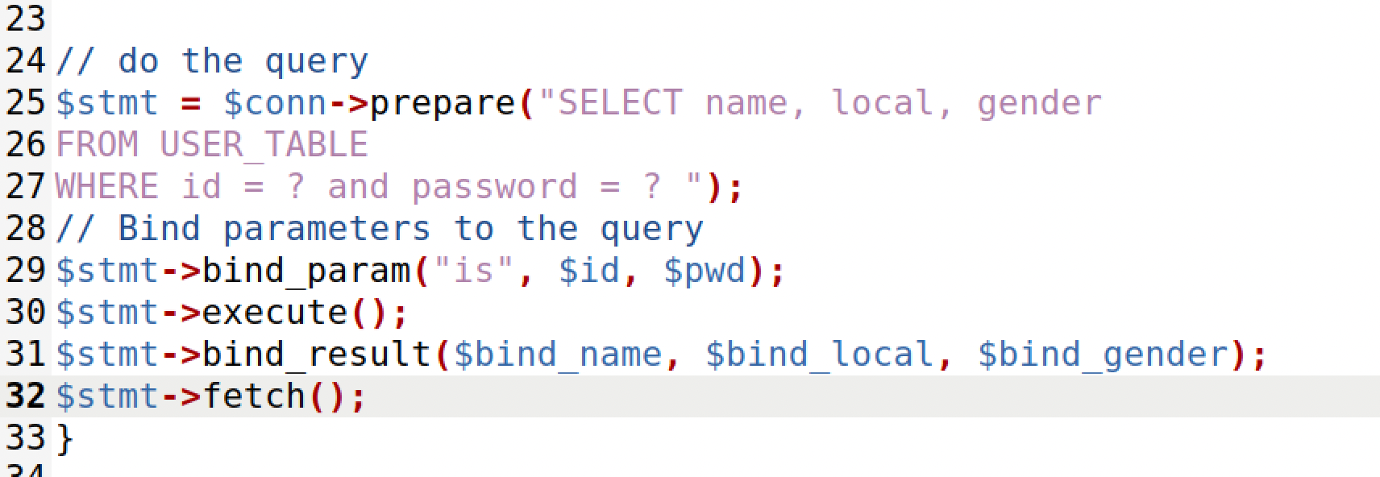

Updating and reloading the containers

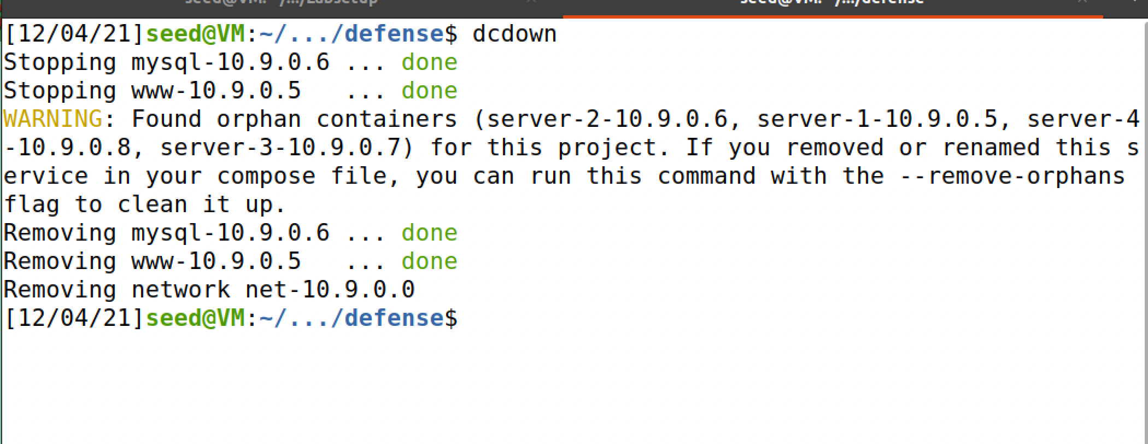

When we try it with the legitimate username and password , we can see that the user profile detail is retrieved.

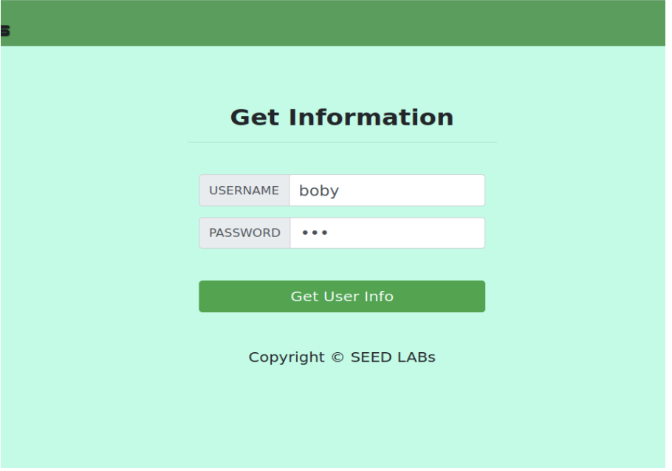

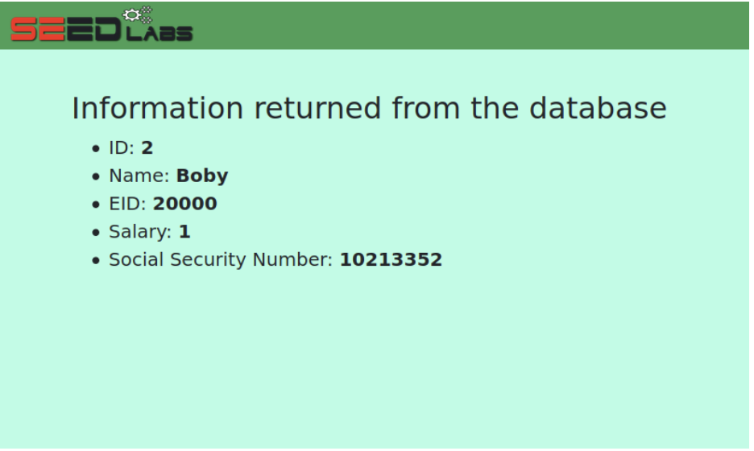

Now we performed the SQL injection in the username using : boby’;# we can that the SQL injection has failed as we are getting a form without any values.

